

**HELLENIC MIGRATION POLICY INSTITUTE**

**The project** **“ACE II“**

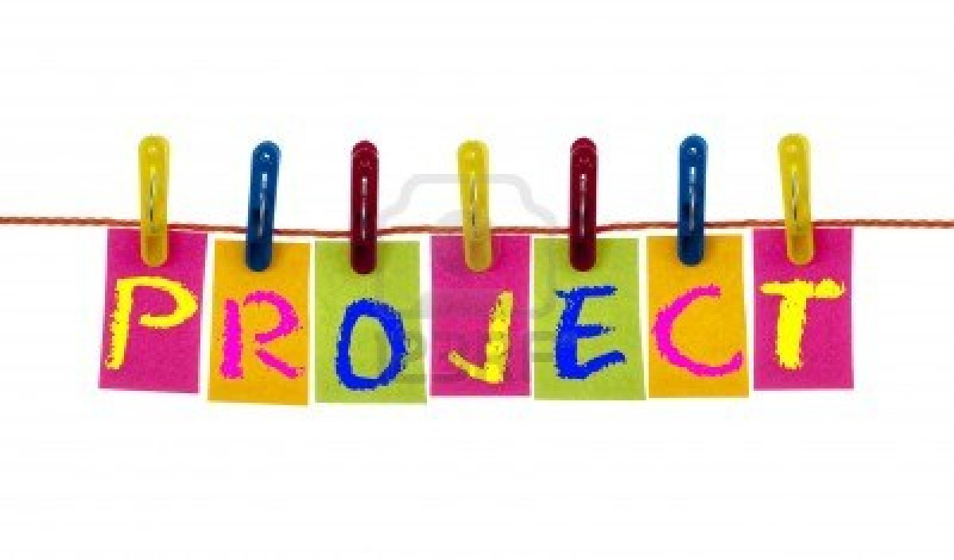

**ACTIVE CITIZEN in EUROPE II**

**Active European citizens building**

**A peer informal pedagogy of HELLENIC MIGRATION POLICY INSTITUTE (I.ME.PO., BENEFICIARY ORGANIZATION) and the PARTNERS**

**Estonia: the NGO MTÜ Lääne-Harju Koostöökogu/ LAG Western-Harju Partnership (LHKK)**

**Lithuania:** **the NGO Mano Europa**

**Romania: the University UNIVERSITATEA DIN PITESTI/ UNIVERSITY OF PITESTI (UPIT)**

**Advance planning visit: 11-12 October 2019**

**Youth Exchange: 7 – 14 November 2019**

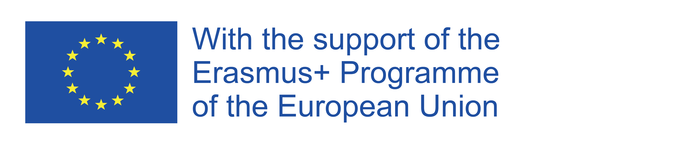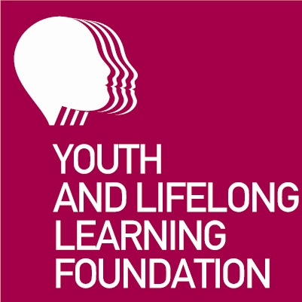

**The project,** as a participative and learner-centred non-formal and informal educational approach, enable young participants, including those with fewer opportunities, to acquire knowledge, skills and essential competences that contribute to their personal and socio-educational development, foster their active participation in society and in democratic life in Europe, thereby improving their employment prospects, intercultural dialogue, social inclusion and solidarity.

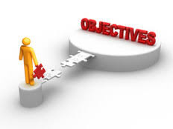

**In the long run** t**he project,** in combination with other similarprojects is expected to have an impact on systems of education, training and youth by offering activities and programmes that better respond to the needs of individuals, within and outside Europe. Thus, it has the objective to increase themotivation foryoung people to take part in futurelearning mobility activities and enhance the capacity of the participating organisations for cooperation and international synergies with youth organisations and various stakeholders in the youth field at national and supranational level for improving the quality in youth work, complement youth systems’ reforms and develop an evidence-based and good practises-focused policy for youth field in accordance with the needs and interests of young people and those of modern labour market.

Overall, the project has the objective to strengthen the interconnections between formal, non-formal and informal education, vocational training and labour market respectively, as well as the better recognition of the certificate youthpass.

The project allows participants to meet and live together for a short period in Greece in order to:

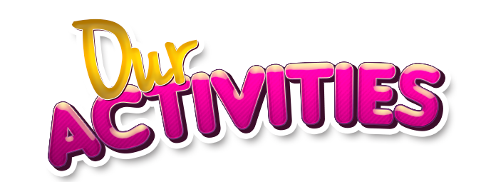

-increase their self-empowerment and self-esteem and the critical autonomic thinking

-enhance the sense of initiatives in work and civic life

-foster the intercultural awareness by discovering new cultures, habits and life-styles, mainly through peer-learning

-support the cooperation and smooth communications in groups with different cultures, habits, ethics, customs, behaviours, life-styles and languages

-promote further the founding EU principles and values like democracy, solidarity, friendship, equality, justice, respect of human rights, tolerance on cultural diversities.

Finally, the project deepens in the strategic communication of European institutions and in the use of social media tools, in particular **Facebook** **of the European Parliament** and **Twitter** **of the European Commission**, which offer upgraded chances for two-way and direct communication, feedback and rapid dissemination of mentioned above information and provide many opportunities for young peopleto acquire competences and grow as responsible democratic individuals and involve as considerate and active citizens in society.

Indicatively the **thematic topics:**

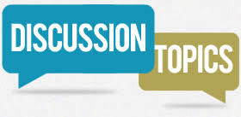

The project, at the first stage, empowers youngsters to apply critical thinking based on Programme Erasmus+ and Key Action for Youth mobility and exchanges, to raise the level of awareness about informal learning and elaborating this thematic area by bringing attention to and learning more about Europass and the Youthpass certificate.

So, the project includes an **Introductory learning unit** **on:**

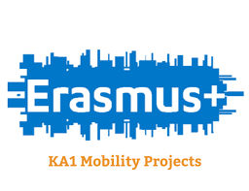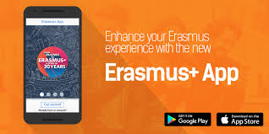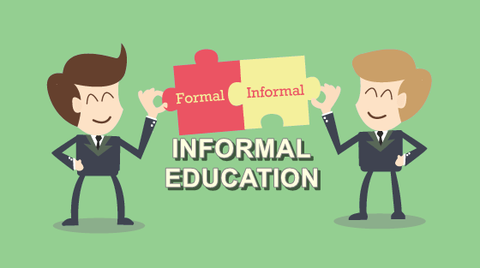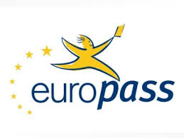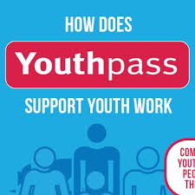

- Erasmus+, Erasmus app and Key Action 1, Awareness and Reflection on Informal Learning

- The certificates Europass και Youthpass

The project has the aim to develop the knowledge about the young participants that is much more than saying names.

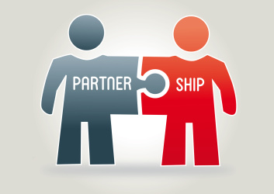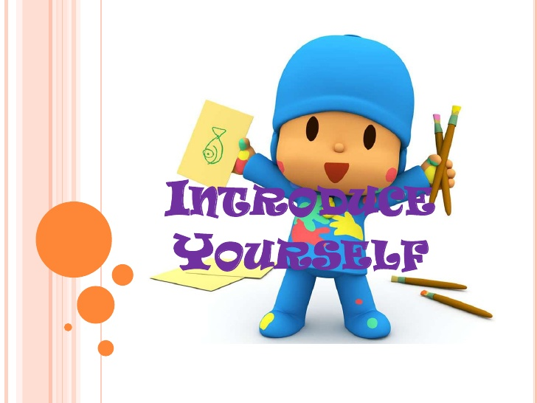

So, the project includes a **Team building unit on**:

- Young participants’ Self portrayals

**MAIN PART – Learning Units**

During the main activity/youth exchange has an intercultural/European dimension and encourages participants to reflect on European topics and to involve in the construction of a more accessible Europe for all.

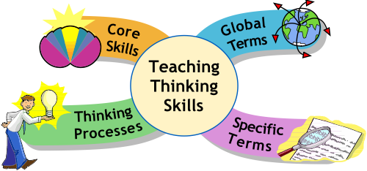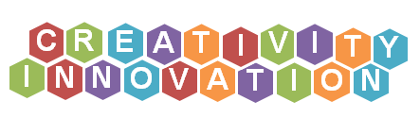

The learning process in the project is triggered by **methods of non-formal and informal education** that are based on totally participatory, methods, intended and voluntary, in an specific field-oriented way,withthe support of the leaders and other professional facilitators, trainers, youth workers, experts in the youth field, volunteers educated as youth trainers, etc, under the auspice of the beneficiary organisation.

The planned, team-centered, cooperative,experiential and active partially activities in the daily timetable, offer space for smooth communication and interaction of young participants, sharing of ideas, avoiding passive listening, allow them to contribute with their own knowledge and skills, thoughts and proposals, and undertake their own researches and analyses. Thus, the participants have chances to:

- identify common values with their peers from different countries in spite of their cultural differences

- challenge viewpoints that perpetuate inequality, distinction, discrimination, treatment or consideration based on the group, class, or category to which a person is perceived to belong (age, colour, disability, ethnicity, gender identity, genetic characteristics, nationality, race religion, sexual orientation, etc

-promote the respect of cultural diversity and fight against racism or xenophobia.

Particularly, **the work programme**, jointly carried out by the participants includes:

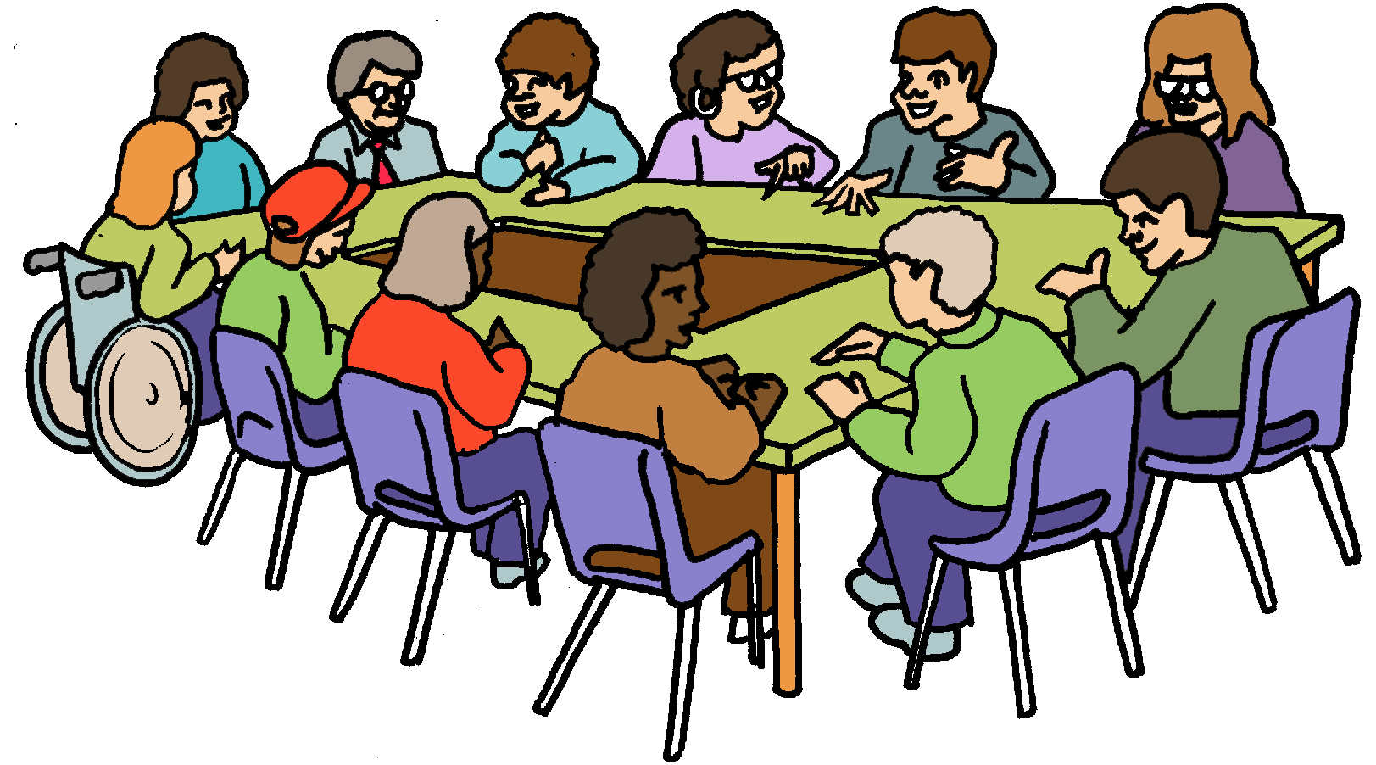

- Lectures workshops enriched with videos, photos, ppt and pptx files, circulars, leaflets, booklets etc

- Discussions in groups, Debates, exchange of ideas and critical thoughts

- Field exercises

- Role-plays, Improvisations

- Audiovisual Screenings, Projections and web interactive tours

- Simulations and online Gaming Happenings, digital Puzzles and web apps

- Outdoor activities – Visits to the European Commission representation and European Parliament offices in Greece.

**Analytically:**

**1st learning unit**

Focus on:

* **Facebook European Parliament:**

1. Erasmus+: Multimedia centre
2. European Youth Event (EYE): Youth ideas for a better future– Youth parliament
3. Current political agenda - press releases and LIVE: hearings
4. Migration policy
5. Parliament's LGBT intergroup
6. Black Ribbon Day
7. International Day of Democracy – Celebrations in Europe

**2nd learning unit**

Focus on:

* **Twitter European Commission:**

1. Funding for youth sector
2. Roaming - The EU "**roam like at home**" rules
3. Current political agenda – press releases
4. The European Citizens' Initiative (ECI)
5. The action: “Have Your Say”
6. Data protection: **cookies**
7. State of the European Union **/S**OTEU 2019
8. White paper for the future of Europe
9. The Greek referendum in 2015
10. BREXIT

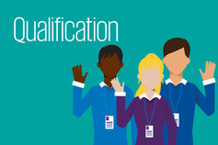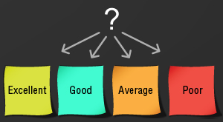

Finally, the young participants reflect on their own learning outcomes from their participation in the activity.

So, the project includes **an Assessment procedure on:**

-Ensuring an awareness and reflection on the learning process and competences developed in the project

- Mapping competencesacquired during the activitythat includes a daily evaluation with structured exploratory questionnaires under the title: "What did we learn today?”

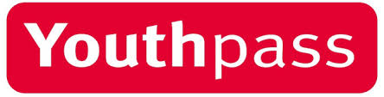

At the end, all the participants receive the Youthpass certificate which recognises their own learning outcomes.

We are glad to host this Youth Exchange/mobilty project that it focuses on the digital image of the united Europe for a better future under the strong belief that the youngsters are going to be benefited in various diverse ways and by sharing their experiences after its finishing, enriching the experience even further.

**We welcome in Greece!**

